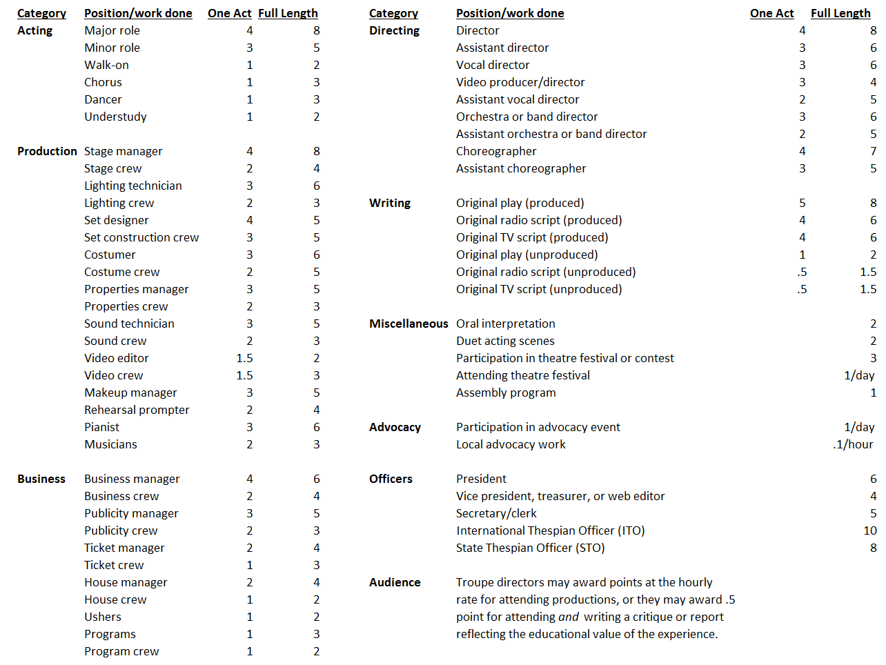
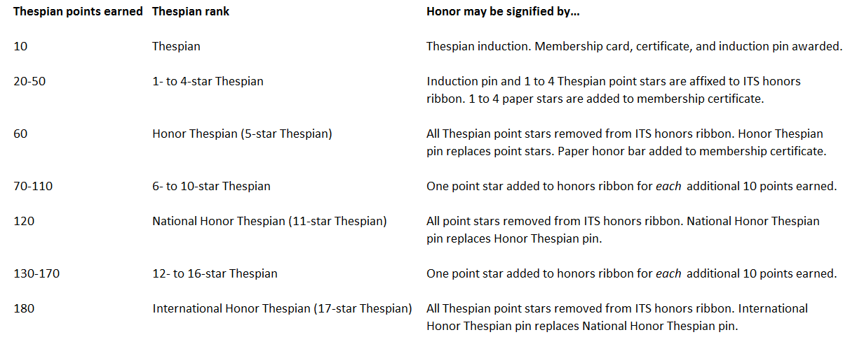
Any points outside of school are worth half credit. You must submit proof.

Desert Vista students must earn 21 points in a single year to be eligible for a letter. All activities must be through Desert Vista, no outside points.
Acting:
Full Length Play/Musical
Major Role 8
Minor Role 5
Chorus 3
Walk-On 2
One Act
Major Role 4
Minor Role 3
Chorus/Walk-on 1
Improv
Member per show 3
Production:
Full Length Play/Musical
Director/Stage Manager 8
Assistant Director 6
Choreographer/Music Director 7
Assistant Choreo/Music Director 5
Head Costumer/Lighting 6
Head Sound/Makeup/Construction 5
Crew/Musicians 3
One Act
Director/Stage Manager 4
Assistant Director 3
Choreographer/Music Director 3
Assistant Choreo/Music Director 2
Head Costumer/Lighting 3
Head Sound/Makeup/Construction 3
Crew/Musicians 2
Club:
Council
President 10
Officer 5
Meetings
Meetings attended 1-5

